**PESTERMINATR: AN ONLINE SERVICE PLATFORM FOR PEST EXTERMINATION**

**AND CONTROL SERVICES**

A Proposal Presented to the Faculty of the

College of Computer Studies, University of Cebu – Main Campus

In Partial Fulfillment for the Requirement for the

Degree Bachelor of Science in Information Technology

**By**

Tude, Christian Neil E.

Tigley, Fhage A.

Buenavista, Julius Jay C.

Engr. Dennis Durano

**Adviser**

Dr. Melvin Niñal

**Dean**

Summer 2019

# **ABSTRACT**

Pesterminatr is an Online Service Platform for Pest Extermination and Control Services. Searching a Pest Control Provider is hassle especially when user do not know their profiles and feedbacks of their services. Searching and deciding their services is time consuming, particularly when user don’t know their service details. Mostly, Pest Control Provider do manual by receiving calls and list those who are requesting for pest extermination. By this study user can easily access in monitoring Pest Control Provider’s services through online. With the use of the system user can easily select a Pest Control Provider, can view their profile and service details. Softwares used in web application were HTML5, CSS3, Bootstrap, PHP7, JavaScript, jQuery, and CodeIgniter. In mobile application the proponents used Android Development Tools, and Java Programming. Like most applications, Pesterminatr never attained perfection due to limited time and resources. The researchers struggle to create an application that can confer with user needs and satisfaction. Pesterminatr has the basic functionalities needed for it to work. These are areas of improvement that is highly recommended for the future researchers that will conduct the same study to do the following that can view list of Pest Control Provider, can review their company details and their given feedbacks by their clients, can select and review their service details, and can request a schedule for ocular inspection and final extermination.

*Keywords: Mobile Application, Web Application, Pest Control Provider, Development Tools*

# **ACKNOWLEDGEMENT**

We are grateful to God for the good health and wellbeing that were necessary to complete this book.

We place on record, our sincere thank you to Dr. Melvin Niñal, Dean of the Faculty, for the continuous encouragement.

We are also grateful to Engr. Dennis Durano, advisee, in the Department of Bachelor of Science in Information Technology. We are extremely thankful and indebted to him for sharing expertise, and sincere and valuable guidance and encouragement extended to us.

We take this opportunity to express gratitude to all of the Department Faculty Members for their help and support. We also thank our parents for the unceasing encouragement, support and attention. We are also grateful to our partners who supported us through this venture.

  We also place on record, our sense of gratitude to one and all, who directly or indirectly, have lent their hand in this venture.

**The Researcher**

# **DEDICATION**

This study is wholeheartedly dedicated to our beloved parents, who have been our source of inspiration and gave us strength when we thought of giving up, who continually provide their moral, spiritual, emotional, and financial support. To our brothers, sisters, relatives, friends, teachers, and classmates who shared their words of advice and encouragement to finish this study. And lastly, we dedicated this book to the Almighty God, thank You for the guidance, strength, power of mind, protection and skills and for giving us a healthy life. All of these, we offer to You.

# **TABLE OF CONTENTS**

**ABSTRACT** ii

**ACKNOWLEDGEMENT** iii

**DEDICATION** iv

**TABLE OF CONTENTS** 5

**LIST OF TABLES** 7

**LIST OF FIGURES** 8

**CHAPTER I** 9

Rationale of the Study 9

Objectives of the Study 11

Scope and Limitations of the Study 12

Significance of the Study 13

Flow of the Study 14

Definition of Terms 15

**CHAPTER II** 17

Related Literature 17

Related Studies 20

Comparative Matrix 21

**CHAPTER III** 22

Software Engineering Methodology 22

Conception-Initiation Phase 23

**Business Model Canvas** 23

**Program Workflow** 24

**Validation Board (Stage 1 and 2)** 27

**Gantt Chart** 29

**Functional Decomposition Diagram** 32

Analysis-Design Phase 33

**Use Case Diagrams** 33

**Story Board** 35

**Database Design** 40

**Entity-Relationship Diagram** 40

**Data Dictionary** 41

Network Design 47

**Network Model** 47

**Network Topology** 47

Build Phase 48

**Technology Stack Diagram** 48

**Program Specification** 49

**List of Modules** 49

Quality Assurance Phase 50

**Unit Testing** 50

**Integration Testing** 51

**Alpha Testing** 52

Deployment Phase 53

**Cost Specification** 53

**Software Specification** 53

**Hardware Specification** 54

**Human Resource Specification** 55

**User Guide** 57

**Installation Guide** 58

**Project Roadmap** 59

**CONCLUSION** 60

**RECOMMENDATIONS** 61

**REFERENCES** 62

**CURRICULUM VITAE** 64

**APPENDICES** 66

Appendix A: Capstone 41 Oath of Confirmation Form 66

Appendix B: Capstone Project Team Composition Form 67

Appendix E: Capstone Project Working Title Form 68

Appendix G: Capstone 41 Logs Form 69

Appendix H: Censor’s Certificate Form 70

# **LIST OF TABLES**

Table 1: Related Studies 20

Table 2: Comparative Matrix 21

Table 3: Validation Board (Stage 1) 27

Table 4: Validation Board (Stage 2) 28

Table 5: Gantt Chart (Caps41) 29

Table 6: Gantt Chart (Caps42) 31

Table 7: Admin Table 41

Table 8: Service Table 41

Table 9: Client Logs Table 41

Table 10: Client Table 42

Table 11: Client Commercial Table 42

Table 12: Comment Table 43

Table 13: Pest Control Logs Table 43

Table 14: Pest Control Table 44

Table 15: Commercial Table 45

Table 16: Schedule Table 45

Table 17: Residential Table 46

Table 18: Square Meter Table 46

Table 19: List of Modules 49

Table 20: Unit Testing 50

Table 21: Integration Testing 51

Table 22: Alpha Testing 52

Table 23: Software Specification 53

Table 24: Hardware Specification 54

# **LIST OF FIGURES**

Figure 1: Flow of the Study 14

Figure 2: Airbnb Homepage 18

Figure 3: Grab Homepage 18

Figure 4: Trivago Homepage 19

Figure 5: Iterative Development 22

Figure 6: Business Model Canvas 23

Figure 7: Program Workflow (User) 24

Figure 8: Program Workflow (Pest Control Provider) 25

Figure 9: Program Workflow (Admin) 26

Figure 10: Functional Decomposition Diagram 32

Figure 11: Use Case Diagram (Pest Control Provider) 33

Figure 12: Use Case Diagram (Client) 34

Figure 13: Use Case Diagram (Admin) 34

Figure 14: Story Board (Landing Page) 35

Figure 15: Story Board (Login Page) 35

Figure 16: Story Board (Register Page) 36

Figure 17: Story Board (Home Page) 36

Figure 18: Mobile (Login Page) 37

Figure 19: Mobile (Register Page) 37

Figure 20: Mobile (Home Page) 38

Figure 21: Mobile (Booking Page) 38

Figure 22: Mobile (Booking Details) 39

Figure 23: Entity-Relationship Diagram 40

Figure 24: Network Model 47

Figure 25: Network Topology 47

Figure 26: Technology Stack Diagram 48

Figure 27: Roadmap 59

# **CHAPTER I**

**INTRODUCTION**

## Rationale of the Study

Pests are organisms that cause serious health problems and also, cause huge damage to the property. Proper pest control is highly needed to resist pest problems from increasing further. These days, to cater to the needs of the people with regard to pest control, many reputed pest control companies have emerged out, providing quality pest control services. These pest controllers use botanical extracts to break the nervous system of the pests and eliminate them from their origin. This method used for pest control is very effective in eradicating the problem of pests for a long duration of time. These pest control treatments are very effective in removing pests effectively from their roots. The experts providing these pest control treatments are highly knowledgeable people and know the right way of implementing such methods, for eliminating the problem of pests effectively for a long duration of time. For more information regarding these pest control service providers and the treatments these pest controllers use to eliminate the problem of pests, get access to the online sources of information (Reed, 2016).

Pesticides are poisons and, unfortunately, they can harm more than just the “pests” at which they are targeted. They are toxic, and exposure to pesticides can not only cause a number of health effects, but is linked to a range of serious illnesses and diseases in humans, from respiratory problems to cancer. Pesticides can cause harmful effects over an extended period, usually following repeated or continuous exposure at low levels. Low doses don’t always cause immediate effects, but over time, they can cause very serious illnesses (Pesticide Action Network UK, 2017).

The fight against agricultural and household pests accompanies the history of humanity, and a total ban on the use of pesticides seems unlikely to happen in the foreseeable future. Currently, about 100,000 different chemicals, inorganic and organic, are currently in the market, grouped according to their function as insecticides, herbicides, fungicides, fumigants, rodenticides, fertilizers, growth regulators, etc. against specific pests, such as snails or human parasites, or their chemical structure—organochlorines, organophosphates, pyrethroids, carbamates, dithiocarbamates, organotin compounds, phthalimides, phenoxy acids, heterocyclic azole compounds, coumarins, etc. Runoff from agricultural land and rain precipitation and dry deposition from the atmosphere can extend exposure to the general environment through the transport of pesticides to streams and ground-water. Also, the prolonged bio-persistence of organochlorines generates their accumulation in the food chain, and their atmospheric drift toward remote geographical areas is mentioned as the cause of elevated fat contents in Arctic mammals. Current regulation in the developed world and the phasing out of more toxic pesticides have greatly reduced the frequency of acute intoxications, although less stringent regulations in the developing world contribute to a complex pattern of exposure circumstances worldwide. Nonetheless, evidence is growing about long-term health effects following high-level, long-lasting exposure to specific pesticides, including asthma and other allergic diseases, immunotoxicity, endocrine disruption, cancer, and central and peripheral nervous system effects. Major reasons for uncertainty in interpreting epidemiological findings of pesticide effects include the complex pattern of overlapping exposure due to multiple treatments applied to different crops and their frequent changes over time to overcome pest resistance. Further research will have to address specific agrochemicals with well-characterized exposure patterns (Cocco, 2016).

Unfortunately, pests have no respect of personal property. You may find them in your home and yard causing all sorts of problems. Don’t allow these bugs to cause destruction. Instead, it’s important to recognize the damage and take action immediately.

With Pesterminatr - it is an Online Service Platform for Pest Extermination and Control Services. Providing the continuing services for pest control solution to both residential and commercial establishments. We offer safe and effective pest extermination service guaranteed. Empowered by service specialists with years of knowledge and experience, we have centered ourselves as a customer-friendly company, providing green solutions to your pest problems.

## Objectives of the Study

**General Objective:**

The main objective of the study is to design and develop a web and mobile application for pest extermination services.

**Specific Objective:**

1. To develop a mobile application that would enable:

**Pest Control Provider**

* To advertise their type of services.
* To view client’s feedbacks.
* To confirm booking schedules.
* To create and manage their account.

**Clients**

* + To view Pest Control Provider for inquires and request for service.
  + To request booking schedule.
  + To create and manage their account.
  + To post ratings and feedbacks.

1. To develop a web application that would enable:

**Pest Control Provider**

* + To accept clients requested schedule.
  + To create and manage their account.
  + To confirm booking schedules.
  + To generate summary report.

**Clients**

* + To view Pest Control Provider inquires and request for service.
  + To give feedbacks.
  + To create and manage their account.

## Scope and Limitations of the Study

This study will focus on the development of a Web and Mobile Based platform for Pest Extermination.

Specifically it covers:

* Booking. Clients can use online booking management.
* Area Calculation. Client must select the area they are going to exterminate.
* Schedule Management. Clients and Pest Control Provider can manage the schedule for pests’ extermination.
* Payment. After service user’s payment is through cash only.
* Information. Pest Control Providers must be fully detailed from their offered services.
* Cancellation. User is allowed to cancel before their booking schedule.
* Feedbacks. Users can view Pest Control Provider’s rating and feedback from different users.

The limitations of this study are the following:

* Pest Control Provider should be licensed, with offline verification of posted certificates.
* Pest Control Provider can’t add **misting** service.
* Client’s payment (**cash**) can be done after service.
* Pest Control Providers are within Cebu City only.
* Notifications and Transactions cannot be managed without internet connection.
* Contracts are between Clients and Pest Control Provider only.
* Access only with Web and Android Application.

## Significance of the Study

The results of the study will be of great benefit to the following:

**Residential Owner**. Pest Control Provider offer a type of service that would inspect your home, offer advice about any pest control problems, perform an initial treatment to rid your home of any existing pests, and design a maintenance program for your home.

**Commercial Establishment**. Pest Control Provider offer a type of service that would provide comprehensive service solutions for every pest that dares to invade your business. They custom fit every commercial pest management solution to your specific business needs in order to keep your facility pest-free.

**Researchers**. This will allow the researchers utilize the knowledge and skills that they learned from the school and enhance their ability to develop software guided by the principles of software development and research.

**Future Researchers**. This project can serve as a reference for the future researchers who are also dealing with the same study. This will also serve as related to pest control provider system or studies guide for conducting further studies for improvement of this study or a development of new study related to this topic.

## Flow of the Study

The Figure 1 shows the process and analysis of the gathered data. Thus, researchers found solutions to solve the problems mentioned in the rationale.

**OUTPUT**

Pesterminatr: An Online Service Platform for Pest Extermination and Control Services

**PROCESS**

* Customer Validation
* Programming Concepts
* Software Engineering Techniques
* Database and Design Concepts
* Lean Startup Methodology
* Iterative Methodology

**INPUT**

* Objectives of the Study
* Related Literature
* Related Studies

**Related Studies**

Aim Pest Control

Select Exterminating

Checka Trade

Figure 1: Flow of the Study

## Definition of Terms

Agrochemicals - a contraction of agricultural chemical, is a chemical product used in agriculture

Arctic - relating to the regions around the North Pole

Botanical - also called plant science(s), plant biology or phytology, is the science of plant life and a branch of biology

Carbamates - is an organic compound derived from carbamic acid

Coumarins - is a fragrant organic chemical compound in the benzopyrone chemical class, although it may also be seen as a subclass

Dithiocarbamates - is a functional group in organic chemistry. It is the analog of a carbamate in which both oxygen atoms are replaced by sulfur atoms

Endocrine Disruption - are chemicals that can interfere with endocrine (or hormone) systems at certain doses. These disruptions can cause cancerous tumors

Eradicating - is derived from Latin word "radix" which means "root"

Fumigants - is use poisonous gas to remove harmful insects, bacteria, disease, etc. from somewhere or something

Fungicides - are biocidal chemical compounds or biological organisms used to kill parasitic fungi or their spores

Herbicides - also commonly known as weedkillers, are chemical substances used to control unwanted plants

Heterocyclic Azole - are a class of five-membered heterocycliccompounds containing a nitrogen atom and at least one other non-carbon atom (i.e. nitrogen, sulfur, or oxygen) as part of the ring

Immunotoxicity - as adverse effects on the functioning of the immune system that result from exposure to chemical substances

Insecticides - are substances used to kill insects

Organochlorines - any of a large group of pesticides and other synthetic organic compounds with chlorinated aromatic molecules

Organophosphates - any organic compound whose molecule contains one or more phosphate ester groups, especially a pesticide of this kind

Organotin - compounds or stannanes are chemical compounds based on tin with hydrocarbon substituents.

Peripheral Nervous System - the nervous system outside the brain and spinal cord

Phenoxy - erbicides (or "phenoxies") are a family of chemicals related to the growth hormone indoleacetic acid (IAA)

Phthalimides - it is the [imide](https://en.wikipedia.org/wiki/Imide) derivative of [phthalic anhydride](https://en.wikipedia.org/wiki/Phthalic_anhydride" \o "Phthalic anhydride). It is a [sublimable](https://en.wikipedia.org/wiki/Sublimation_(phase_transition)" \o "Sublimation (phase transition)) white solid that is slightly soluble in water but more so upon addition of [base](https://en.wikipedia.org/wiki/Base_(chemistry))

Pyrethroids - is an organic compound similar to the natural pyrethrins produced by the flowers of pyrethrums

Rodenticides - colloquially rat poison, are typically non-specific pest control chemicals made and sold for the purpose of killing rodents

Toxic - denoting or relating to debt that has a high risk of default

# **CHAPTER II**

**REVIEW RELATED LITERATURE AND STUDIES**

## Related Literature

Online booking systems are designed to provide all the features of self-service portals. Potential guests book services based on the open dates suggested by the system. Of course, you should have personalized customer care support to handle various queries. Still, with a well-maintained reservation system, you’ll rarely need to deal with customers directly (Asenova, 2018).

At its most basic, an [online booking system](https://www.bookinglive.com/) is software which allows a potential customer to book and pay for an activity or service directly through your website. That means from the moment a customer decides they want to book to choosing a date, picking a time and paying for the booking, everything is handled online, greatly reducing the workload on your staff and removing the opportunity for double-bookings (Johnston, 2017).

One advantage of booking a hotel, flight or car rental online is the convenience. Being able to make all your travel plans on the Internet means you can do it any time of the day or night at home, or while you're on your lunch break at the office. Customers on the go can even make bookings on their smartphones or tablets. There's no need for lengthy phone calls or visits to a travel agency -- with just a few minutes and a click of the mouse, you'll have all your plans finalized (Oakley, n.d.).

An online booking system is not a contact form on your website, or a payment form which sends you an email with a confirmation request.  A booking system automates the process.  When a booking is made it reduces the number of available slots or places on a specific tour or activity.  You should also be able to track online versus offline sales, sales by staff member and even give local partners like hotel concierges or tourist offices logins so they can make bookings without contacting you.  This is a big advantage for an online booking system (Mallen, 2014).

Online booking system facilitates remote bookings and instant payments which is convenient to both; booker and the facility provider. Unlike traditionally, bookings can happen round the clock and all the information can be directly entered into the system which reduces human errors. Online booking systems ensure convenience and comfort to guests and a peace of mind. No last minute rush to find a hotel and fear of all rooms being filled up (Technosys, n.d.).

**Related Studies**

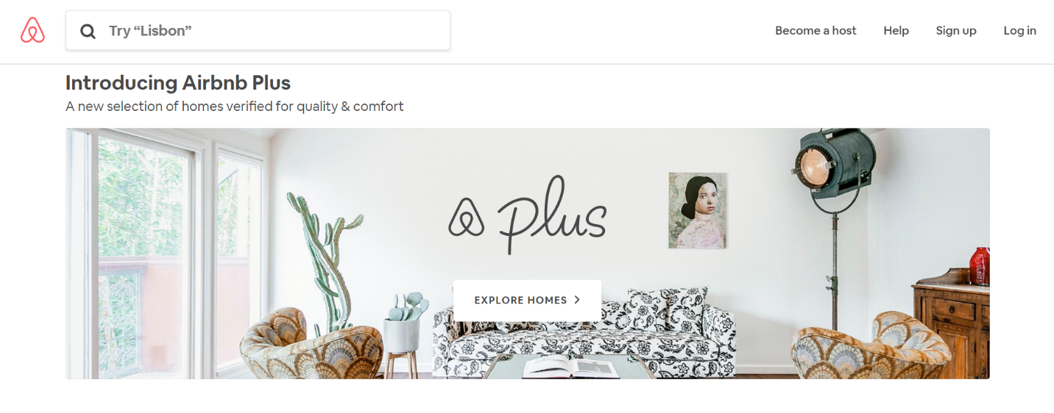

Figure 2: Airbnb Homepage

Airbnb Clone, being developed, replicating the core functionality's of the very famous Airbnb Portal, is an online marketplace, allowing its users to search for A-class properties across the globe and avail the luxuries of a niche lifestyle.



Figure 3: Grab Homepage

Because for them, transportation is a right, not a privilege. That’s why they worked really hard to create a platform that caters to their every need, regardless of income, age, or special needs: choices, door to door, and anywhere anytime. That’s what they call their drivers. Not workers. Not contractors. But partners. And they want to give them a way to earn enough to have options in life. They want to make a profit, yes. But never at their expense.



Figure 4: Trivago Homepage

Whether you are an online travel agency, a hotel chain or an independent hotel, trivago has a range of marketing tools and services to help your business to learn, grow and be competitive in our online marketplace. From improving your hotel profile to referring quality traffic to your booking site, we have you covered.

Table 1: Related Studies

## Related Studies

|  |  |  |  |  |  |
| --- | --- | --- | --- | --- | --- |
| **Related Studies** | **Features** | **Limitations** | **Platform** | **Support** | **Monetization** |
| **Name: Airbnb**  **URL:** [**https://www.airbnb.com/**](https://www.airbnb.com/)  **Year: 2017**  **Proponent: Brian Chesky, Nathan Blecharczyk, Joe Gebbia** | A vacation rental and lodging script*.* | The space is accurately represented, located where the host says it is, and is bookable by the host. | Web and Mobile | Web and Mobile | Subscription |
| **Name: Grab**  **URL: https://www.grab.com/ph/**  **Year: 2012**  **Proponent: Anthony Tan** | Launches ‘Better 365’, a new campaign to improve drivers’ experience in four ways: better support, increased earnings, better tools and a stronger community | You may only access the Service using authorized means. | Web and Mobile | Web and Mobile | Subscription |
| **Name: Trivago**  **URL: https://www.trivago.com.ph/**  **Year: 2005**  **Proponent: Abhinav Kumar** | To be the traveler’s first and independent source of information for finding the ideal hotel. | Are valid for all services that trivago provides hoteliers in connection with the entries in the hotel databank on trivago Hotel Manager. | Web and Mobile | Web and Mobile | Subscription |

Table 2: Comparative Matrix

## Comparative Matrix

|  |  |  |  |  |  |
| --- | --- | --- | --- | --- | --- |
| **Features** | **Airbnb** | **Grab** | **Trivago** | **Pesterminatr** | **Total %** |
| **Mobile Support** | ✓ | ✓ | ✓ | ✓ | 100% |
| **Web Support** | ✓ | ✓ | ✓ | ✓ | 100% |
| **Ratings and Feedbacks or Comments** | ✓ | ✓ | ✓ | ✓ | 100% |
| **View Pest Control Provider** |  |  |  | ✓ | 25% |
| **Book using *Mobile Application*** | ✓ | ✓ | ✓ | ✓ | 25% |
| **Total %** | 80% | 80% | 80% | 100% |  |

# **CHAPTER III**

**RESEARCH METHODOLOGY**

## Software Engineering Methodology

**Initial Planning**

**Deployment**

Figure 5: Iterative Development

**Iterative Development** is a way of breaking down the software development of a large application into smaller chunks. In iterative development, feature code is designed, developed and tested in repeated cycles. With each iteration, additional features can be designed, developed and tested until there is a fully functional software application ready to be deployed to customers (Rouse, Tech Target, 2011).

## Conception-Initiation Phase

### **Business Model Canvas**

It is a strategic management and lean startup template for developing new or documenting existing business models. It is a visual chart with elements describing a firms or product's value proposition, infrastructure, customers, and finances (Osterwalder, 2010).

|  |  |  |  |  |
| --- | --- | --- | --- | --- |
| **Key Partners**  Pest Control Provider | **Key Activities**  To develop a social network website.  To develop a mobile application | **Value Proposition**  Online Booking  Mobile-based Area Calculation  Automated User Profile Management  Online Schedule Management | **Customer Relationship**  Transactional  Community | **Customer Segments**  Residential Owner  Commercial Establishment  Pest Control Provider |
| **Key Resources**  Human Resources  Pesterminatr Platform  Web Hosting | **Channels**  Mobile Application  Pesterminatr Development |
| **Cost Structure**  Maintenance  Platform Development | | **Revenue Stream**  Advertisement  Commission | |

Figure 6: Business Model Canvas

### **Program Workflow**

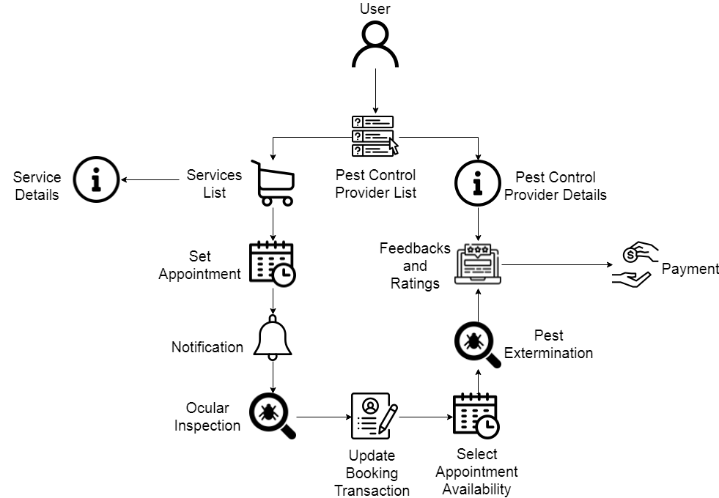

Figure 7: Program Workflow (User)

Once the Client is already registered to our system. They can view the listed Pest Control Provider, every Pest Control Provider has their own services with details and prices. The User set an appointment for ocular inspections, once the Pest Control Provider accepted the User’s request they will notify them. Once they are done in inspecting their problems, they will update what the User inputted in booking details and select schedule from the Pest Control Provider’s availability for final pest exterminations. After exterminating pest, they can give feedbacks and ratings through mobile. And finally your payment.

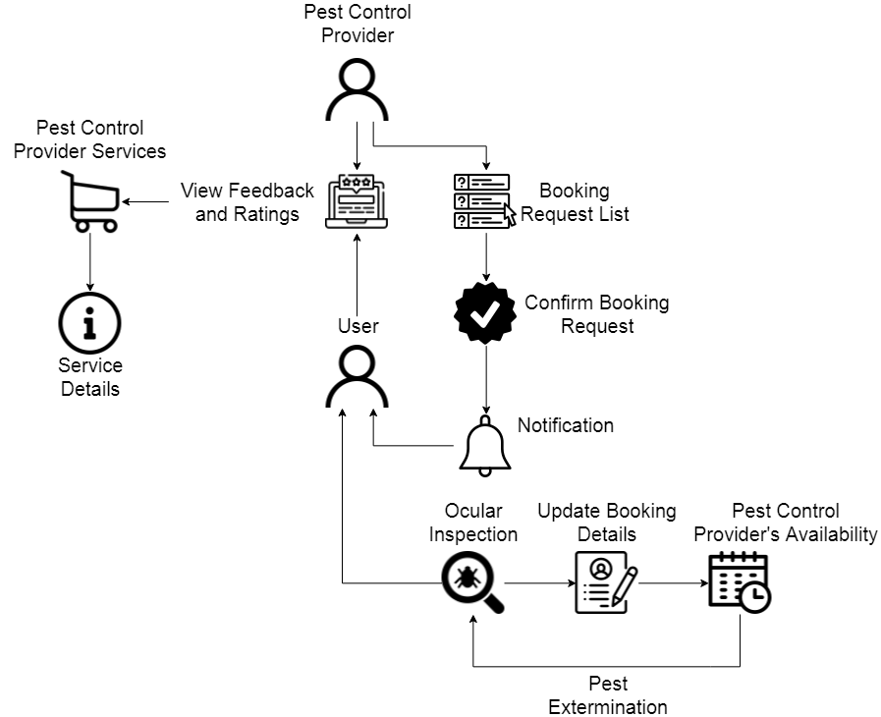

Figure 8: Program Workflow (Pest Control Provider)

Pest Control Provider can view client’s feedback and ratings from after service. Pest Control Provider have their also different services with details and prices. They are the ones who will approve their client’s request ocular inspections, once they are done inspecting they will update client’s booking details and select new appointment through mobile – the availability of Pest Control Provider for final Pest Extermination.

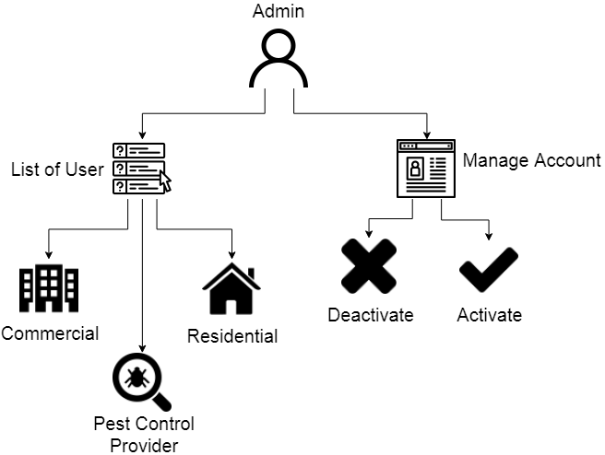

Figure 9: Program Workflow (Admin)

Pesterminatr will be the one who will manage their User’s account by deactivating or activating account, and the list of their different Users.

### **Validation Board (Stage 1 and 2)**

Table 3: Validation Board (Stage 1)

|  |  |  |  |
| --- | --- | --- | --- |
| **Customer** | **Pest Control Provider** | **Pest Control Provider** | **Pest Control Provider** |
| **Problem** | They have difficulties to manage customer’s request – mostly through call process | They will not be too aware because of lacking information (their manual process) or needs by the customer | Some of their customer finds further information about their service |
| **Solution** |  |  |  |
| **Riskiest Assumption** | The problem exist | The problem exist | The problem exist |
| **Success Criteria** | 70% | 70% | 70% |
| **Results and Discussion** |  |  |  |
| **Learnings** | Pest Control Provider can’t easily manage their customer request by using calls or manuals | Pest Control Provider doing manual where you can use a website for you to be ease | Pest Control Provider has to have an online service information for them not to less their time to explain more their customers |

STAGE 1

Table 4: Validation Board (Stage 2)

STAGE 2

|  |  |  |  |
| --- | --- | --- | --- |
| **Customer** | **Pest Control Provider** | **Pest Control Provider** | **Pest Control Provider** |
| **Problem** | They have difficulties to manage customer’s request – mostly through call process | They will not be too aware because of lacking information (their manual process) or needs by the customer | Some of their customer finds further information about their service |
| **Solution** | Pesterminatr is an online service platform that can manage your customer’s request through online | Pesterminatr is an online service platform that can collect all necessary information for booking | Pesterminatr is an online service platform that has an informational site that makes their customer understands more of their offered services |
| **Riskiest Assumption** | The problem exist | The problem exist | The problem exist |
| **Success Criteria** | 70% | 70% | 70% |
| **Results and Discussion** | 80% | 70% | 80% |
| **Learnings** | Pest Control Provider can’t easily manage their customer request by using calls or manuals | Pest Control Provider doing manual where you can use a website for you to be ease | Pest Control Provider has to have an online service information for them not to less their time to explain more their customers |

|  |
| --- |
|  |
|  |

### **Gantt Chart**

Estimated Time Duration

Actual Time Duration

Table 5: Gantt Chart (Caps41)

|  |  |  |  |  |  |  |  |  |  |  |  |  |  |  |  |  |  |  |  |  |  |  |  |
| --- | --- | --- | --- | --- | --- | --- | --- | --- | --- | --- | --- | --- | --- | --- | --- | --- | --- | --- | --- | --- | --- | --- | --- |
| **#** | **Task Name** | **Task Lead** | **Start Date** | **End Date** | **July**  **2018** | | | | **August**  **2018** | | | | | **September**  **2018** | | | | | **October**  **2018** | | | | |
|  |  |  |  |  | 1 | 2 | 3 | 4 | 1 | 2 | 3 | 4 | 1 | | 2 | 3 | 4 | 1 | | 2 | 3 | 4 |
| 1 | Title Hearing | All | July 12 | July 12 |  |  |  |  |  |  |  |  |  | |  |  |  |  | |  |  |  |
| July 12 | July 13 |  |  |  |  |  |  |  |  |  | |  |  |  |  | |  |  |  |
| 2 | Rationale of the Study | Hustler | July 16 | July 20 |  |  |  |  |  |  |  |  |  | |  |  |  |  | |  |  |  |
| July 16 | July 27 |  |  |  |  |  |  |  |  |  | |  |  |  |  | |  |  |  |
| 3 | Objectives of the Study | All | July 19 | August 3 |  |  |  |  |  |  |  |  |  | |  |  |  |  | |  |  |  |
| July 19 | August 3 |  |  |  |  |  |  |  |  |  | |  |  |  |  | |  |  |  |
| 4 | Scope and Limitation of the Study | Hustler | August 6 | August 10 |  |  |  |  |  |  |  |  |  | |  |  |  |  | |  |  |  |
| August 6 | August 14 |  |  |  |  |  |  |  |  |  | |  |  |  |  | |  |  |  |
| 5 | Significance of the Study | Hustler | August 18 | August 18 |  |  |  |  |  |  |  |  |  | |  |  |  |  | |  |  |  |
| August 18 | August 18 |  |  |  |  |  |  |  |  |  | |  |  |  |  | |  |  |  |
| 6 | Flow of the Study | Hustler | August 18 | August 18 |  |  |  |  |  |  |  |  |  | |  |  |  |  | |  |  |  |
| August 18 | August 18 |  |  |  |  |  |  |  |  |  | |  |  |  |  | |  |  |  |
| 7 | Definition of Terms | Hustler | August 18 | August 18 |  |  |  |  |  |  |  |  |  | |  |  |  |  | |  |  |  |
| August 18 | August 18 |  |  |  |  |  |  |  |  |  | |  |  |  |  | |  |  |  |
| 8 | Validation Board | All | August 20 | August 21 |  |  |  |  |  |  |  |  |  | |  |  |  |  | |  |  |  |
| August 20 | August 22 |  |  |  |  |  |  |  |  |  | |  |  |  |  | |  |  |  |
| 9 | Business Model Canvas |  | August 22 | August 23 |  |  |  |  |  |  |  |  |  | |  |  |  |  | |  |  |  |
| August 22 | Sept 5 |  |  |  |  |  |  |  |  |  | |  |  |  |  | |  |  |  |
| 10 | Functional Decomposition Diagram | All | Sept 6 | Sept 8 |  |  |  |  |  |  |  |  |  | |  |  |  |  | |  |  |  |
| Sept 6 | Sept 19 |  |  |  |  |  |  |  |  |  | |  |  |  |  | |  |  |  |
| 11 | Use Case Diagram | All | Sept 10 | Sept 15 |  |  |  |  |  |  |  |  |  | |  |  |  |  | |  |  |  |
| Sept 10 | Sept 17 |  |  |  |  |  |  |  |  |  | |  |  |  |  | |  |  |  |
| 12 | Entity Relationship Diagram | All | Sept 19 | Sept 22 |  |  |  |  |  |  |  |  |  | |  |  |  |  | |  |  |  |
| Sept 19 | Sept 23 |  |  |  |  |  |  |  |  |  | |  |  |  |  | |  |  |  |
| 13 | Data Dictionary | Hipster | Sept 28 | Sept 28 |  |  |  |  |  |  |  |  |  | |  |  |  |  | |  |  |  |
| Sept 28 | Sept 28 |  |  |  |  |  |  |  |  |  | |  |  |  |  | |  |  |  |
| 14 | Software Engineering Methodology | Hustler | Sept 29 | Sept 30 |  |  |  |  |  |  |  |  |  | |  |  |  |  | |  |  |  |
| Sept 29 | Sept 30 |  |  |  |  |  |  |  |  |  | |  |  |  |  | |  |  |  |
| 15 | Software Specification | Hustler | Oct 1 | Oct 3 |  |  |  |  |  |  |  |  |  | |  |  |  |  | |  |  |  |
| Oct 1 | Oct 2 |  |  |  |  |  |  |  |  |  | |  |  |  |  | |  |  |  |
| 16 | Hardware Specification | Hipster | Oct 1 | Oct 2 |  |  |  |  |  |  |  |  |  | |  |  |  |  | |  |  |  |
| Oct 1 | Oct 2 |  |  |  |  |  |  |  |  |  | |  |  |  |  | |  |  |  |
| 17 | Technology Stack Diagram | Hipster | Oct 2 | Oct 4 |  |  |  |  |  |  |  |  |  | |  |  |  |  | |  |  |  |
| Oct 3 | Oct 3 |  |  |  |  |  |  |  |  |  | |  |  |  |  | |  |  |  |
| 18 | List of Modules | Hipster | Oct 3 | Oct 5 |  |  |  |  |  |  |  |  |  | |  |  |  |  | |  |  |  |
| Oct 3 | Oct 4 |  |  |  |  |  |  |  |  |  | |  |  |  |  | |  |  |  |
| 19 | Network Design | Hacker | Oct 4 | Oct 5 |  |  |  |  |  |  |  |  |  | |  |  |  |  | |  |  |  |
| Oct 4 | Oct 4 |  |  |  |  |  |  |  |  |  | |  |  |  |  | |  |  |  |
| 20 | Network Model | Hacker | Oct 4 | Oct 7 |  |  |  |  |  |  |  |  |  | |  |  |  |  | |  |  |  |
| Oct 7 | Oct 8 |  |  |  |  |  |  |  |  |  | |  |  |  |  | |  |  |  |
| 21 | Review of Related Literature | Hustler | Oct 8 | Oct 8 |  |  |  |  |  |  |  |  |  | |  |  |  |  | |  |  |  |
| Oct 8 | Oct 10 |  |  |  |  |  |  |  |  |  | |  |  |  |  | |  |  |  |
| 22 | Related Studies | Hustler | Oct 8 | Oct 10 |  |  |  |  |  |  |  |  |  | |  |  |  |  | |  |  |  |
| Oct 8 | Oct 10 |  |  |  |  |  |  |  |  |  | |  |  |  |  | |  |  |  |
| 23 | Program Flow | All | Oct 8 | Oct 10 |  |  |  |  |  |  |  |  |  | |  |  |  |  | |  |  |  |
| Oct 8 | Oct 10 |  |  |  |  |  |  |  |  |  | |  |  |  |  | |  |  |  |
| 24 | Story Board | Hipster | Oct 10 | Oct 10 |  |  |  |  |  |  |  |  |  | |  |  |  |  | |  |  |  |
| Oct 10 | Oct 10 |  |  |  |  |  |  |  |  |  | |  |  |  |  | |  |  |  |
| 25 | Gantt Chart | Hustler | Oct 10 | Oct 10 |  |  |  |  |  |  |  |  |  | |  |  |  |  | |  |  |  |
| Oct 10 | Oct 10 |  |  |  |  |  |  |  |  |  | |  |  |  |  | |  |  |  |
| 26 | Explainer Video | Hustler | Oct 13 | Oct 13 |  |  |  |  |  |  |  |  |  | |  |  |  |  | |  |  |  |
| Oct 13 | Oct 13 |  |  |  |  |  |  |  |  |  | |  |  |  |  | |  |  |  |
| 27 | Test Plan | Hipster | Oct 13 | Oct 13 |  |  |  |  |  |  |  |  |  | |  |  |  |  | |  |  |  |
| Oct 13 | Oct 13 |  |  |  |  |  |  |  |  |  | |  |  |  |  | |  |  |  |
| 28 | Bibliography | Hustler | Oct 13 | Oct 13 |  |  |  |  |  |  |  |  |  | |  |  |  |  | |  |  |  |
| Oct 13 | Oct 13 |  |  |  |  |  |  |  |  |  | |  |  |  |  | |  |  |  |
| 29 | Proposal Hearing | All | October 19 | October 19 |  |  |  |  |  |  |  |  |  | |  |  |  |  | |  |  |  |
| October 19 | October 19 |  |  |  |  |  |  |  |  |  | |  |  |  |  | |  |  |  |

|  |  |  |  |  |  |  |  |  |  |  |  |  |  |  |  |  |  |  |  |  |  |  |  |  |
| --- | --- | --- | --- | --- | --- | --- | --- | --- | --- | --- | --- | --- | --- | --- | --- | --- | --- | --- | --- | --- | --- | --- | --- | --- |
| Pesterminatr | | | | | Duration in Weeks | | | | | | | | | | | | | | | | | | | |
| **November** | | | | **December** | | | | **January** | | | | **February** | | | | **March** | | | |
| **Task #** | **Description** | **Start Date** | **End Date** | **Duration** | 1 | 2 | 3 | 4 | 1 | 2 | 3 | 4 | 1 | 2 | 3 | 4 | 1 | 2 | 3 | 4 | 1 | 2 | 3 | 4 |
| 1 | Design Phase | Nov 5/18 | Dec 17/18 | 49 Days |  |  |  |  |  |  |  |  |  |  |  |  |  |  |  |  |  |  |  |  |
| 2 | Implementation Phase | Dec 3/18 | Feb 25/19 | 82 Days |  |  |  |  |  |  |  |  |  |  |  |  |  |  |  |  |  |  |  |  |
| 3 | Testing Phase | Jan 15/19 | Feb 13/19 | 37 Days |  |  |  |  |  |  |  |  |  |  |  |  |  |  |  |  |  |  |  |  |
| 4 | Finalizing Phase | Feb 8/19 | Feb 28/19 | 27 Days |  |  |  |  |  |  |  |  |  |  |  |  |  |  |  |  |  |  |  |  |
| 5 | Deployment Phase | Feb 26/19 | March 4/19 | 7 Days |  |  |  |  |  |  |  |  |  |  |  |  |  |  |  |  |  |  |  |  |

Table 6: Gantt Chart (Caps42)

### **Functional Decomposition Diagram**

Figure 10: Functional Decomposition Diagram

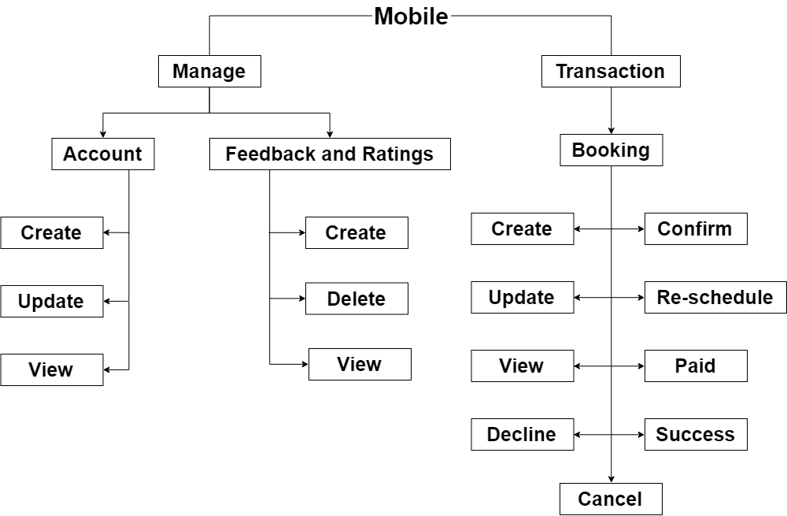

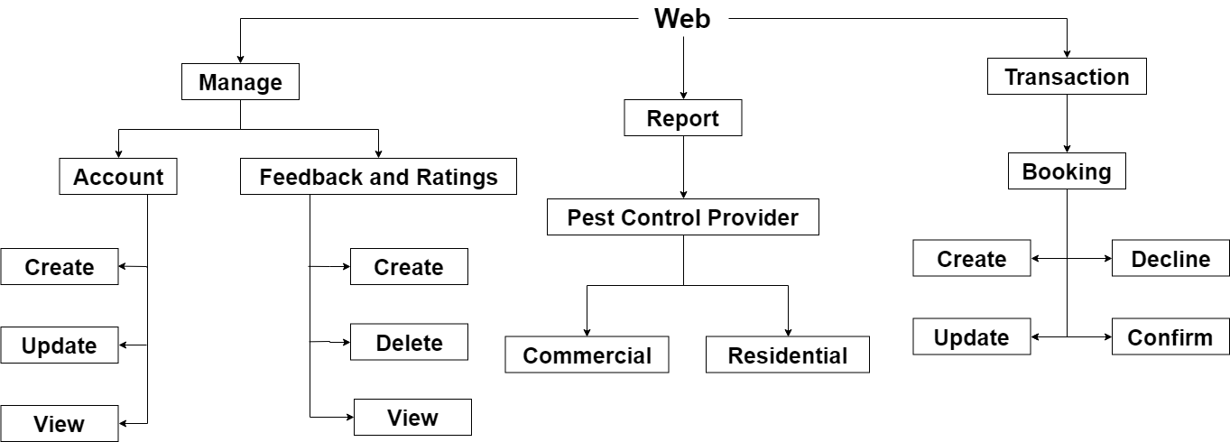

These diagram shows a hierarchical organization of the proposed system functions that comprises the system operation. The proponents used this model to show how the system is organized into lower-level processes. These processes translate into program modules during application development.

## Analysis-Design Phase

### **Use Case Diagrams**

A use case diagram is a graphic depiction of the interactions among the elements of a system (Rouse, WhatIs, 2015).

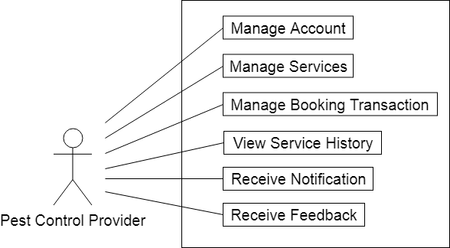

Figure 11: Use Case Diagram (Pest Control Provider)

**Pest Control Provider** to manage their account, to manage their different services, to manage multiple clients requested appointments where they are the one who will manage booking transaction, to view their service history, to receive notifications and to receive feedbacks from different clients. .

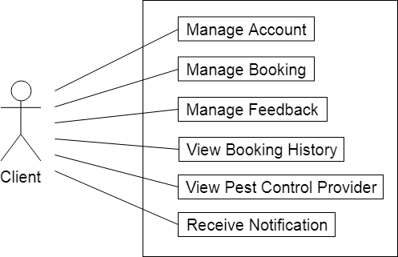

Figure 12: Use Case Diagram (Client)

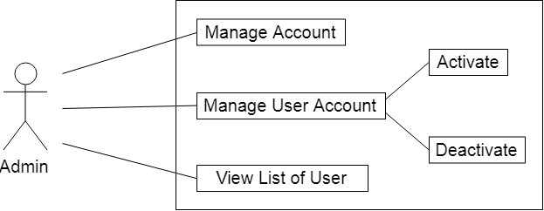**Clients** of Pest Control Provider to manage their account, before they request a type of service they must have their own account to access for bookings. To manage their bookings, to manage their feedbacks to the selected Pest Control Provider, to view their booking history from the past services they inquired, to receive notifications and to view different Pest Control Provider with their details.

Figure 13: Use Case Diagram (Admin)

**Admin** to manage their own account, to manage user account where they can activate or deactivate different users and to view list of User – Residential, Commercial Establishment and Pest Control Provider.

### **Story Board**

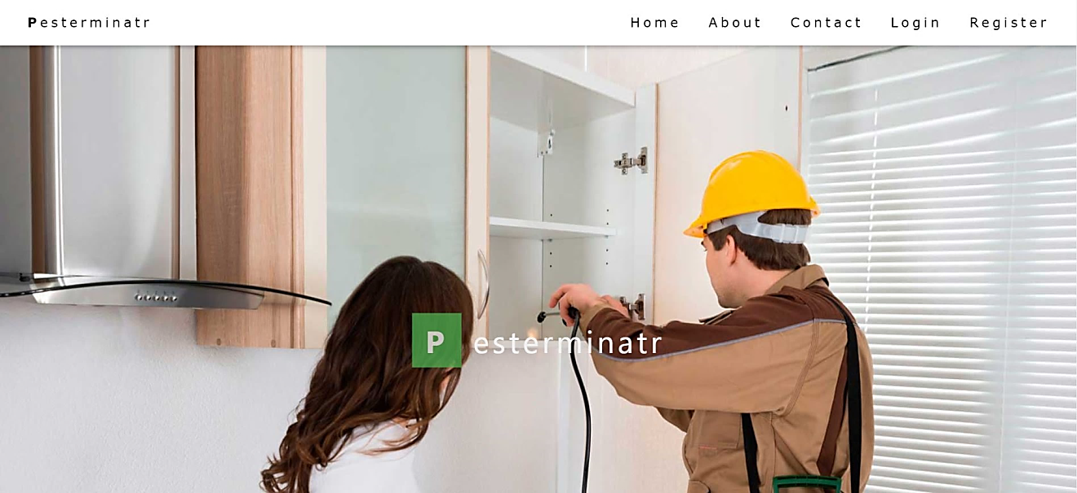

Figure 14: Story Board (Landing Page)

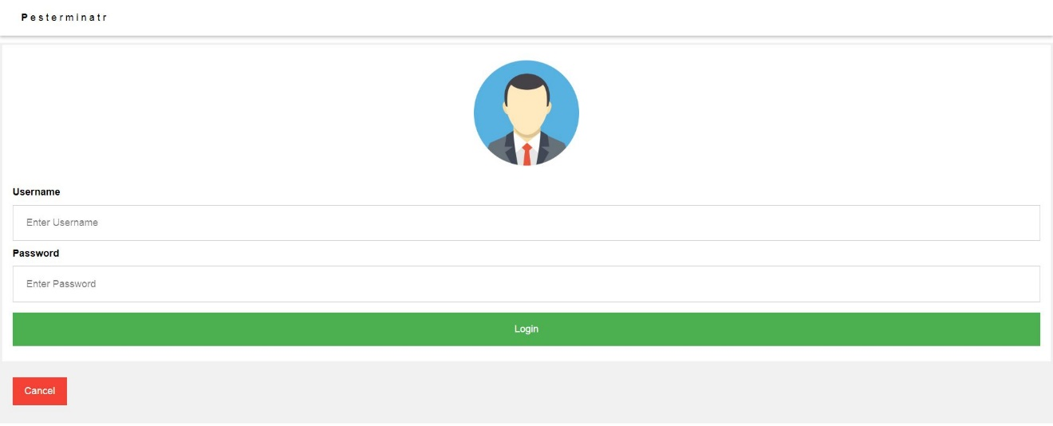

Figure 15: Story Board (Login Page)

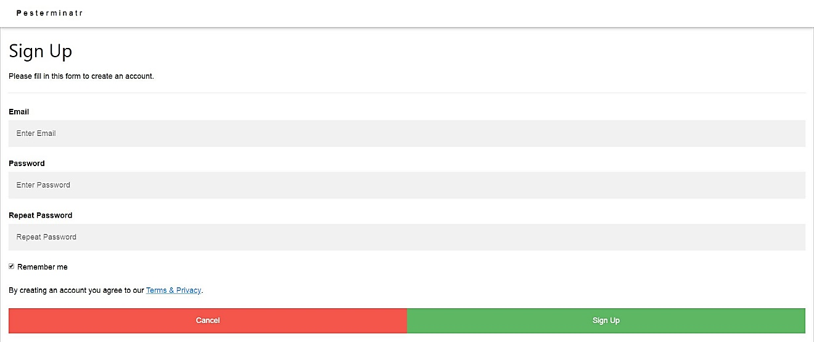

Figure 16: Story Board (Register Page)

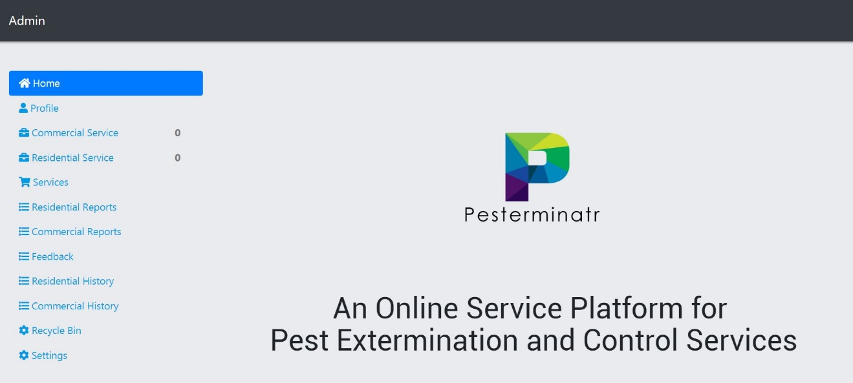

Figure 17: Story Board (Home Page)

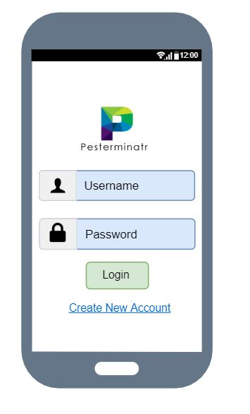

Figure 18: Mobile (Login Page)

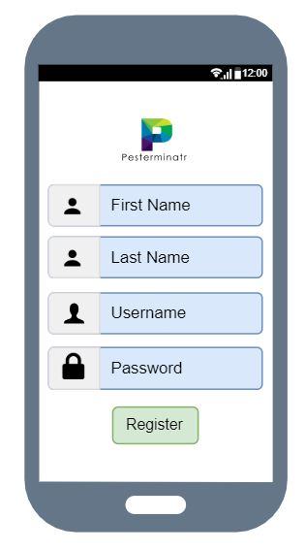

Figure 19: Mobile (Register Page)

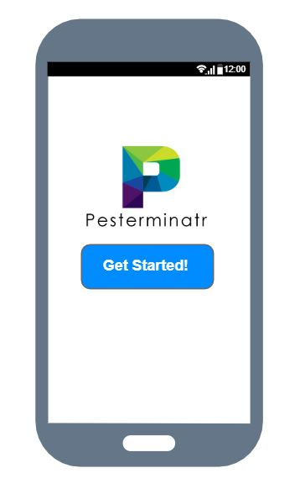

Figure 20: Mobile (Home Page)



Figure 21: Mobile (Booking Page)

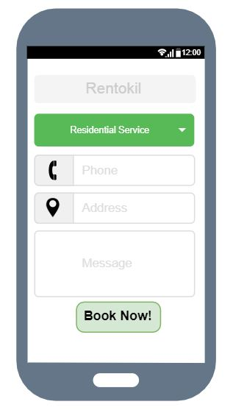

Figure 22: Mobile (Booking Details)

### **Database Design**

### **Entity-Relationship Diagram**

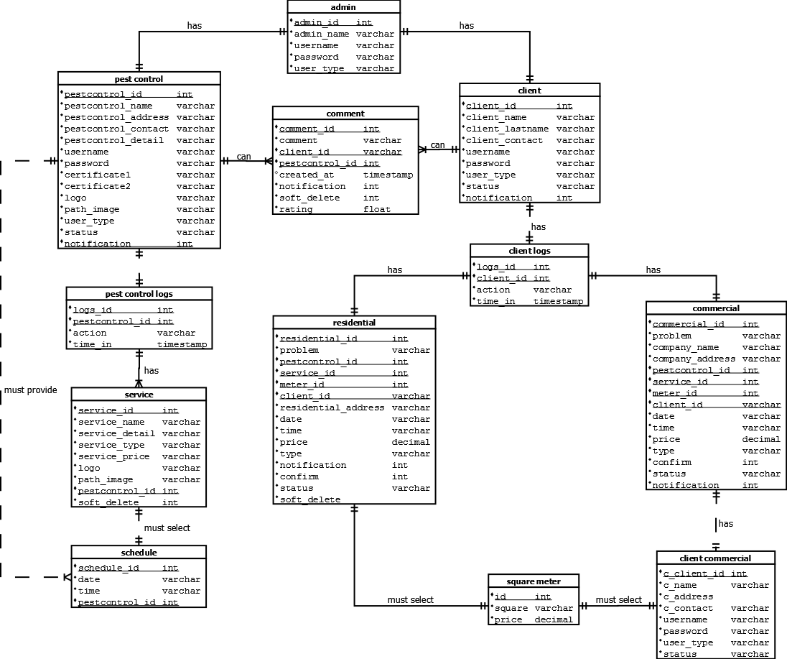

Figure 23: Entity-Relationship Diagram

### **Data Dictionary**

Table 7: Admin Table

ADMIN TABLE

|  |  |  |  |  |
| --- | --- | --- | --- | --- |
| **Field Name** | **Data Type** | **Length** | **Null** | **Description** |
| **Admin_id** | Int | 11 | Not null | Admin id, primary key, auto increment |
| **Admin_name** | Varchar | 255 | Not null | Admin name |
| **Username** | Varchar | 255 | Not null | Admin username |
| **Password** | Varchar | 255 | Not null | Admin password |
| **User_type** | Varchar | 255 | Not null | Admin type |

Table 8: Service Table

SERVICE TABLE

|  |  |  |  |  |
| --- | --- | --- | --- | --- |
| **Field Name** | **Data Type** | **Length** | **Null** | **Description** |
| **Service_id** | Int | 11 | Not null | Service id, primary key, auto increment |
| **Service_name** | Varchar | 255 | Not null | Service name |
| **Service_detail** | Varchar | 255 | Not null | Service detail |
| **Service_type** | Varchar | 255 | Not null | Service type |
| **Service_price** | Varchar | 255 | Not null | Service price |
| **Logo** | Varchar | 255 | Not null | Service logo |
| **Path_image** | Varchar | 255 | Not null | Service path image |
| **Pestcontrol_id** | Int | 11 | Not null | Pest Control id, foreign key |
| **Soft_delete** | Int | 11 | Not null | Service soft delete |

Table 9: Client Logs Table

CLIENT LOGS TABLE

|  |  |  |  |  |
| --- | --- | --- | --- | --- |
| **Field Name** | **Data Type** | **Length** | **Null** | **Description** |
| **Logs_id** | Int | 11 | Not null | Logs id, primary key, auto increment |
| **Client_id** | Int | 11 | Not null | Client id, foreign key |
| **Action** | Varchar | 255 | Not null | Client last name |
| **Time_in** | Timestamp |  | Not null | Client address |

Table 10: Client Table

CLIENT TABLE

|  |  |  |  |  |
| --- | --- | --- | --- | --- |
| **Field Name** | **Data Type** | **Length** | **Null** | **Description** |
| **Client_id** | Int | 11 | Not null | Client id, primary key, auto increment |
| **Client_name** | Varchar | 255 | Not null | Client name |
| **Client_lastname** | Varchar | 255 | Not null | Client last name |
| **Client_address** | Varchar | 255 | Not null | Client address |
| **Client_contact** | Varchar | 255 | Not null | Client contact |
| **Username** | Varchar | 255 | Not null | Client username |
| **Password** | Varchar | 255 | Not null | Client password |
| **User_type** | Varchar | 255 | Not null | Client user type |
| **Status** | Varchar | 255 | Not null | Client status |
| **Notification** | Int | 11 | Not null | Client notification |

Table 11: Client Commercial Table

CLIENT COMMERCIAL TABLE

|  |  |  |  |  |
| --- | --- | --- | --- | --- |
| **Field Name** | **Data Type** | **Length** | **Null** | **Description** |
| **C_client_id** | Int | 11 | Not null | Commercial Client id, primary key, auto increment |
| **C_name** | Varchar | 255 | Not null | Commercial Client name |
| **C_Address** | Varchar | 255 | Not null | Commercial Client address |
| **Username** | Varchar | 255 | Not null | Commercial Client username |
| **password** | Varchar | 255 | Not null | Commercial Client password |
| **User_type** | Varchar | 255 | Not null | Commercial Client user type |
| **Status** | Varchar | 255 | Not null | Commercial Client status |

Table 12: Comment Table

COMMENT TABLE

|  |  |  |  |  |
| --- | --- | --- | --- | --- |
| **Field Name** | **Data Type** | **Length** | **Null** | **Description** |
| **Comment_id** | Int | 11 | Not null | Comment id, primary key, auto increment |
| **Comment** | Varchar | 255 | Not null | Comment |
| **Client_id** | Varchar | 255 | Not null | Client id, foreign key, auto increment |
| **Pestcontrol_id** | Int | 11 | Not null | Pest Control id, foreign key, auto increment |
| **Created_at** | Timestamp |  | Not null | Comment created at |
| **Notification** | Int | 11 | Not null | Comment notification |
| **Soft_delete** | Int | 11 | Not null | Comment soft delete |
| **rating** | Float |  | Not null | Comment rating |

Table 13: Pest Control Logs Table

PEST CONTROL LOGS TABLE

|  |  |  |  |  |
| --- | --- | --- | --- | --- |
| **Field Name** | **Data Type** | **Length** | **Null** | **Description** |
| **Logs_id** | Int | 11 | Not null | Logs id, primary key, auto increment |
| **Pestcontrol_id** | Int | 11 | Not null | Pest Control id, foreign key |
| **Action** | Varchar | 255 | Not null | Pest Control Logs action |
| **Time_in** | Timestamp |  | Not null | Pest Control Logs time in |

Table 14: Pest Control Table

PEST CONTROL TABLE

|  |  |  |  |  |
| --- | --- | --- | --- | --- |
| **Field Name** | **Data Type** | **Length** | **Null** | **Description** |
| **Pestcontrol_id** | Int | 11 | Not null | Pest Control id, primary key, auto increment |
| **Pestcontrol_name** | Varchar | 255 | Not null | Pest Control name |
| **Pestcontrol_address** | Varchar | 255 | Not null | Pest Control address |
| **Pestcontrol_contact** | Varchar | 255 | Not null | Pest Control contact |
| **Pestcontrol_detail** | Varchar | 255 | Not null | Pest Control detail |
| **Username** | Varchar | 255 | Not null | Pest Control username |
| **Password** | Varchar | 255 | Not null | Pest Control password |
| **Certificate1** | Varchar | 255 | Not null | Pest Control certificate1 |
| **Certificate2** | Varchar | 255 | Not null | Pest Control certificate2 |
| **Logo** | Varchar | 255 | Not null | Pest Control logo |
| **Path_image** | Varchar | 255 | Not null | Pest Control path image |
| **User_type** | Varchar | 255 | Not null | Pest Control user type |
| **Status** | Varchar | 255 | Not null | Pest Control status |
| **Notification** | Int | 11 | Not null | Pest Control notification |

Table 15: Commercial Table

COMMERCIAL TABLE

|  |  |  |  |  |
| --- | --- | --- | --- | --- |
| **Field Name** | **Data Type** | **Length** | **Null** | **Description** |
| **Commercial_id** | Int | 11 | Not null | Commercial id, primary key, auto increment |
| **Problem** | Varchar | 11 | Not null | Commercial problem |
| **Company_name** | Varchar | 255 | Not null | Commercial name |
| **Company_address** | Varchar | 255 | Not null | Commercial address |
| **Pescontrol_id** | Int | 11 | Not null | Pest Control id, foreign key |
| **Service_id** | Int | 11 | Not null | Service id, foreign key |
| **Meter_id** | Int | 11 | Not null | Meter id, foreign key |
| **Client_id** | Varchar | 255 | Not null | Client id, foreign key |
| **Date** | Varchar | 255 | Not null | Commercial date |
| **Time** | Varchar | 255 | Not null | Commercial time |
| **Price** | Decimal | 9, 2 | Not null | Commercial price |
| **Type** | Varchar | 255 | Not null | Commercial type |
| **Confirm** | Int | 11 | Not null | Commercial confirm |
| **Status** | Varchar | 255 | Not null | Commercial status |
| **Notification** | Int | 11 | Not null | Commercial notification |
| **Soft_delete** | Int | 11 | Not null | Commercial soft delete |

Table 16: Schedule Table

SCHEDULE TABLE

|  |  |  |  |  |
| --- | --- | --- | --- | --- |
| **Field Name** | **Data Type** | **Length** | **Null** | **Description** |
| **Schedule_id** | Int | 11 | Not null | Schedule id, primary key, auto increment |
| **Date** | Varchar | 255 | Not null | Admin name |
| **Time** | Varchar | 255 | Not null | Admin username |
| **Pestcontrol_id** | Int | 11 | Not null | Admin password |

Table 17: Residential Table

RESIDENTIAL TABLE

|  |  |  |  |  |
| --- | --- | --- | --- | --- |
| **Field Name** | **Data Type** | **Length** | **Null** | **Description** |
| **Residential_id** | Int | 11 | Not null | Residential id, primary key, auto increment |
| **Problem** | Varchar | 255 | Not null | Residential problem |
| **Pestcontrol_id** | Int | 11 | Not null | Pest Control id, foreign key |
| **Service_id** | Int | 11 | Not null | Service id, foreign key |
| **Meter_id** | Int | 11 | Not null | Meter id, foreign key |
| **Client_id** | Varchar | 255 | Not null | Client id, foreign key |
| **Residential_address** | Varchar | 255 | Not null | Residential address |
| **Date** | Varchar | 255 | Not null | Residential date |
| **Time** | Varchar | 255 | Not null | Residential time |
| **Price** | Decimal | 9, 2 | Not null | Residential price |
| **Type** | Varchar | 255 | Not null | Residential type |
| **Notification** | Int | 11 | Not null | Residential notification |
| **Confirm** | Int | 11 | Not null | Residential confirm |
| **Status** | Varchar | 255 | Not null | Residential status |
| **Soft_delete** | Int | 11 | Not null | Residential soft_delete |

Table 18: Square Meter Table

SQUARE METER TABLE

|  |  |  |  |  |
| --- | --- | --- | --- | --- |
| **Field Name** | **Data Type** | **Length** | **Null** | **Description** |
| **Id** | Int | 11 | Not null | Square Meter id, primary key, auto increment |
| **Square** | Varchar | 255 | Not null | Square Meter square |
| **Price** | Decimal | 9, 2 | Not null | Square Meter price |

## Network Design

### **Network Model**

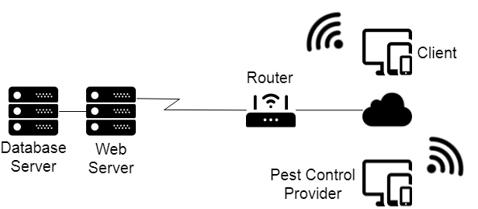

Figure 24: Network Model

**Network Design** is an iterative process, encompassing topological design, network-synthesis, and network-realization, and is aimed at ensuring that a new telecommunications network or service meets the needs of the subscriber and operator (Wikipedia, 2018).

### **Network Topology**

Figure 25: Network Topology

## Build Phase

### **Technology Stack Diagram**

Pesterminatr is to be developed on two platforms; the web and mobile platform. Since it going to be on two platforms, it has categorized its software specification into two respectively.

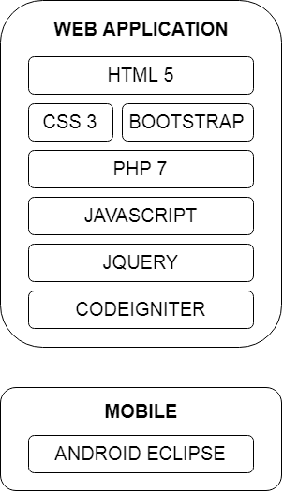

Figure 26: Technology Stack Diagram

### **Program Specification**

### **List of Modules**

Table 19: List of Modules

|  |  |  |  |  |
| --- | --- | --- | --- | --- |
| **Programmer** | **Modules** | **Pest Control Provider** | **Client** | **Administrator** |
|  | **Account Management** | | | |
| Create Account | * | * | * |
| Update Account | * | * | * |
| Activate/Deactivate Account |  |  | * |
| View Account | * | * | * |
| Notification |  |  | * |
| Total | 1 | 1 | 1 |
| **Booking Management** | | | |
| Create Booking |  | * |  |
| Cancel Booking |  | * |  |
| Confirm Booking | * |  |  |
| View Booking | * | * |  |
| Update Booking | * | * |  |
|  |  |  |  |
| Total | 1 | 1 | 0 |
| **Feedback Management** | | | |
| Rate PCP |  | * |  |
| Post Feedback | * | * |  |
| View Feedback | * | * |  |
| Update Feedback | * | * |  |
| Delete Feedback |  | * | * |
| Monitor Rate and Review |  |  | * |
| Total | 1 | 1 | 1 |
| **Service Management** | | | |
| Create Service | * |  |  |
| Update Service | * |  |  |
| Delete Service | * |  |  |
| View Service | * | * |  |
| Total | 1 | 1 | 0 |
| **Service History Management** | | | |
| View Service History | * | * | * |
| Total | 1 | 1 | 1 |
| Number of Modules per User | 5 | 5 | 3 |
| **Total Number of Modules** | **13** | | |

## Quality Assurance Phase

### **Unit Testing**

It is a software development process in which Pesterminatr tested its smallest testable parts.

Table 20: Unit Testing

|  |  |  |  |  |  |  |  |
| --- | --- | --- | --- | --- | --- | --- | --- |
| **Module Name** | **Unit Name** | **Date Tested** | **Test Case ID** | **Test Case Description** | **Expected Result** | **Actual Result** | **Remarks** |
| Account Management | Login | 12/3/2018 | U1 | Valid Account | Successfully Login | Performed as Expected | Passed |
| Account Management | Login | 12/3/2018 | U2 | Valid Account | An error message must be displayed | Performed as Expected | Passed |
| Account Management | Login | 12/3/2018 | U3 | Invalid Account | An error message must be displayed | Performed as Expected | Passed |
| Account Management | Login | 12//3/2018 | U4 | Empty Fields | An error message must be displayed | Performed as Expected | Passed |
| Account Management | Create Account | 12/3/2018 | U5 | Valid Inputted Details | Successfully created new account | Performed as Expected | Passed |
| Account Management | Create Account | 12/3/2018 | U6 | Invalid Inputted Details | An error message must be displayed | Performed as Expected | Passed |
| Account Management | Create Account | 12/3/2018 | U7 | Incomplete Fields | An error message must be displayed | Performed as Expected | Passed |
| Account Management | Create Account | 12/3/2018 | U8 | Account Already Exist | An error message must be displayed | Performed as Expected | Passed |
| Account Management | Update Account | 12/3/2018 | U9 | Valid Input | Successfully Updated Account | Performed as Expected | Passed |
| Account Management | Update Account | 12/3/2018 | U10 | Invalid Input | An error message must be displayed | Performed as Expected | Passed |
| Account Management | Update Account | 12/3/2018 | U11 | Incomplete Fields | An error message bust be displayed | Performed as Expected | Passed |
| Account Management | Change Password | 12/3/2018 | U12 | Valid Input | Successfully Changed | Performed as Expected | Passed |

### **Integration Testing**

It is also a software development process in which Pesterminatr combined program units and tested it in groups in multiple ways.

Table 21: Integration Testing

|  |  |  |  |  |  |  |
| --- | --- | --- | --- | --- | --- | --- |
| **Test Case ID** | **Module 1** | **Integration Process** | **Module 2** | **Pre-condition** | **Results** | **Remarks** |
| I13 | Booking Management | Create Booking | Feedback Management | Rate PCP | Performed as Expected | Passed |
| I14 | Booking Management | Cancel Booking | Feedback Management | Post Feedback | Performed as Expected | Passed |
| I15 | Booking Management | Confirm Booking | Feedback Management | View Feedback | Performed as Expected | Passed |
| I16 | Booking Management | View Booking | Feedback Management | Update Feedback | Performed as Expected | Passed |
| I17 | Booking Management | Update Booking | Feedback Management | Delete Feedback | Performed as Expected | Passed |
| I18 | Service Management | Create Service | Feedback Management | Monitor Rate and Review | Performed as Expected | Passed |
| I19 | Service Management | Update Service | Service History Management | View Service History | Performed as Expected | Passed |
| I20 | Service Management | Delete Service |  |  | Performed as Expected | Passed |
| I21 | Service Management | View Service |  |  | Performed as Expected | Passed |

### **Alpha Testing**

This is the testing of an application when development is about to complete. Minor design changes can still be made as a result of alpha testing. Alpha Testing is typically performed by a group that is independent of the design team, but still within the company, e.g. in-house software test engineers, or software SQ engineers.

Table 22: Alpha Testing

|  |  |  |  |  |
| --- | --- | --- | --- | --- |
| **Testing Criteria** | **Poor** | **Fair** | **Good** | **Very Good** |
| *Graphical User Interface (GUI)* | | | | |
| Consistency (The user interface is of the same formatting style and icons throughout the system.) |  |  | ✓ |  |
| Reusability (The system contains reusable GUI components such as familiar buttons, text and check boxes, and other tools.) |  |  |  | ✓ |
| Forgiveness and Tolerance (The interface displays message or confirmation prompts that would allow users to undo or redo critical actions.) |  |  |  | ✓ |
| Simplicity (The GUI design include simple GUI buttons, such as simple screens with clear, uncrowded messages.) |  |  |  | ✓ |
| Readability (The interface has appropriate colors, font sizes, and styles that is convenient to the users.) |  |  | ✓ |  |
| Clarity (Displayed error, help, and warning messages are clear, concise, and as elementary as possible to assist user in operating the software.) |  | ✓ |  |  |
| Flexibility (The system includes user preferences setting to allow changes, for example, increasing the font size.) |  | ✓ |  |  |
| User-friendliness (The GUI design must be user-friendly, by providing helpful, courteous, and non-offending messages.) |  |  | ✓ |  |
| *System Performance* | | | | |
| Conformance to the Requirements (The system effectively met all the identified features and/or requirements.) |  |  | ✓ |  |
| Conformance to the Objectives (All specific objectives of the system are met by the program.) |  |  | ✓ |  |
| Efficiency (the entire system functions efficiently. It doesn’t have delay in any transaction.) |  | ✓ |  |  |
| Security (the system is secured. Login details are authenticated. Input parameters are ensured prior to the execution of the next transaction. ) |  |  | ✓ |  |
| Integrity (The software allows the registered user to have control over its own private information.) |  |  | ✓ |  |
| Overall Impression (In general, the program or system is functional and useful.) |  |  | ✓ |  |

## Deployment Phase

It contains the budget cost, what specifications used and the guides for the user and installation of Pesterminatr;

### **Cost Specification**

To determine the possible cost that will be invested on the proposed system and how we can benefit from it. As we go further in our development journey, part of our expenses goes to infrastructure 39 for web hosting in order for our system to have a popularity over the internet. We will be earning our revenue from subscription fee from the users.

### **Software Specification**

Table 23: Software Specification

|  |  |
| --- | --- |
| **DEVELOPER** | |
| **WEB** | |
| Operating System | Windows 7 or higher |
| Web Server | Localhost |
| Web Development Tools | HTML 5, PHP 7, Bootstrap, Laravel, Google Map API |
| Image Editing Tool | Adobe Photoshop CS6 or higher |
| Code Editor Tools | Sublime 3 and Visual Studio Code |
| Web Browser | Google Chrome, Mozilla Firefox, Internet Explorer, Etc. |
| Internet Connection | 1mbps or higher |
| **MOBILE** | |
| Operating System | Android 4.0 Ice Cream Sandwich or higher |
| Mobile Development Tools | Android Eclipse |
| **USER** | |
| **WEB** | |
| Operating System | Windows 7 or higher |
| Web Server | Google Chrome, Mozilla Firefox, Internet Explorer, Etc. |
| Internet Connection | 1mbps or higher |
| **MOBILE** | |
| Operating System | Android 4.0 Ice Cream Sandwich or higher |
| Mobile Development Tool | Android Eclipse |
| Internet Connection | 1mbps or higher |

A **software requirements** specification is a description of a software system to be developed. It is modeled after business requirements specification, also known as a stakeholder requirements specification (Wikipedia, 2018). Pesterminatr, is to be developed on two platforms; the web and mobile platform. Since it going to be on two platforms, it has categorized its software specification into two respectively.

### **Hardware Specification**

|  |  |
| --- | --- |
| **DEVELOPER** | |
| **WEB** | |
| CPU | Intel® Pentium® CPU G640 2.80GHz or Higher |
| RAM | 4 GB or higher |
| Hard Disk Driver | 500 GB or higher |
| Keyboard | Standard Keyboard |
| Mouse | Standard Mouse |
| Video | Intel® HD Graphics or Higher |
| **MOBILE** | |
| Operating System | Android 4.0 Ice Cream Sandwich or higher |
| Storage Space | 1GB or higher |
| Memory | 1 GB RAM or Higher |
| **USER** | |
| **WEB** | |
| CPU | Intel® Pentium® CPU G640 2.80GHz or Higher |
| RAM | 4 GB or higher |
| Hard Disk Driver | 500 GB or higher |
| Keyboard | Standard Keyboard |
| Mouse | Standard Mouse |
| Video | Intel® HD Graphics or Higher |
| **MOBILE** | |
| Operating System | Android 4.0 Ice Cream Sandwich or higher |
| Storage Space | 1GB or higher |
| Memory | 1 GB RAM or Higher |

Table 24: Hardware Specification

Computer **hardware specifications** are technical descriptions of the computer’s components and capabilities. Processor speed, model and manufacturer. Processor speed is typically indicated in gigahertz (GHz). The higher the number, the faster the computer. Random Access Memory (RAM). This is typically indicated in gigabytes (GB).

The more RAM in a computer the more it can do simultaneously. Hard disk (sometimes called ROM) space. This is typically indicated in gigabytes (GB) and refers generally to the amount of information (like documents, music and other data) your computer can hold. Other specifications might include network ( ethernet or wi-fi) adapters or audio and video capabilities (Me and My Shadow, 2015).

### **Human Resource Specification**

A statement of employee characteristics and qualifications required for satisfactory performance of defined duties and tasks comprising a specific job or function. It describes the person you want to hire for a particular job. It helps in the recruitment & selection process, evaluating the performance of employees and in their appraisal & promotion.

Positions Required

1. Project Manager (PM)

• Implementing the exact needs of the client, based on the knowledge of organization they are representing.

• Planning and scheduling for each stage of the project.

• Demonstrate sufficient knowledge and experience to appropriately apply a methodology to projects that have reasonably well defined project requirements and deliverables.

• Implementing of management plan on to the project.

• Good at handling multiple tasks at the same time, have excellent skills and capable of leading the team.

• Expertise in handling all aspects of the project.

• Prepare and organize various resources including individuals to ensure that the project finish on time, stay within budget and meet corresponding requirements.

• Planning, procurement and execution of a project.

• Striving to maintain the progress, mutual interaction and tasks of various parties in such a way reducing the risk of overall failure, maximizes benefits, and minimizes costs.

• Defining and communicating project objectives that are clear, useful and attainable.

• Managing the project team which includes facilitating commitment and productivity, removing obstacles, and motivating team members.

• Managing Expectations which includes accomplishing of project objectives, managing stakeholder, managing provider and communicating project status, milestones, and managing unexpected project conflicts effectively.

• Managing the constraints of the project management triangle, which are cost, time, scope and quality.

1. System Analysts/Database Designers (SA/DD) 40

• Responsible of checking that all parts of the system are coordinated based on a complete and traceable Software Requirements Specifications (SRS).

• Writing of technical requirements from a critical phase.

• Works designs and implements computer databases for the collection, protection and analysis of data.

• Identifying, understanding and planning of organizational and human impacts of planned systems, and ensure that new technical requirements are properly integrated with existing processes and skill sets.

• Planning a system flow from the ground up.

• Interact with internal users and draw up detailed design documentation including charts and diagrams that indicate the various components involved.

• Help programmers during system development, e.g. provide use cases, flowcharts or even database design.

• Analyzing data inquiry needs, ensuring security of information and organizing layout to best present the information needed.

• Performing of system testing.

• Document requirements or contribute to user manuals.

• Responsible for designing components and providing that information to the developer whenever a development process is conducted.

• Works well with the Project Manager.

1. Network Designers/UI Designers (ND/UID)

• Responsible for the mastery of the system’s network design/ deployment diagram.

• Responsible for preparing information’s to be contained in the interface and creating functional and visually appealing user interfaces for websites, databases, computer programs and applications.

• Ensures that GUI design must be user-friendly.

• Works well with the Systems Analyst.

1. Software Engineers/Programmers (SE/P)

• Applies the principle of software engineering to the design, development, maintenance, testing, and evaluation of the software and the systems.

• Must be capable of designing, writing, and testing of computer programs.

• Familiarity of different software programs and the ability to learn and use new software efficiently is a must.

• Acquire skills to write code and create software programs that command computers to accomplish certain tasks.

• Responsible for the development, maintenance and operation of computer software to enable businesses and organizations to function efficiently.

• Capable of rewriting, debugging, maintaining and testing programs.

• Works well with Systems Analyst and UI Designer to identify the needs of a company and to develop the specifications of the engineering project.

1. QA Testers

• Ensures the quality of the software product and helps find and eliminate any bugs.

• Responsible for determining the functionality of every aspect of a particular application.

• Test and find for bugs in the software, from complete crashes to minor glitches in the program.

• Responsible for assuring quality of the final product before any public use of the system. • Look for program bugs may it is spelling mistakes, localization problems.

• Works well with Systems Analyst, UI Designer and Software Engineer.

### **User Guide**

**Customer Perspective**

1. Register – Click “Register” button, provide the required information and submit.
2. Complete Name is required.
3. Address is required.
4. Username is required.
5. Password is required.
6. Login – Click “Login” button, provide the required information and submit.
7. Username is required.
8. Password is required.

**Pest Control Provider Perspective**

1. Register – Click “Register” button, provide the required information and submit.
2. Complete Name is required.
3. Address is required.
4. Username is required.
5. Password is required.
6. Login – Click “Login” button, provide the required information and submit.
7. Username is required.
8. Password is required.
9. Provide certificates for confirmation.
10. Upload certificate is required.
11. Must be .jpg or .png format.
12. Profile – Click “Update Profile” button, provide the required information and update.
13. Complete Address is required.
14. Contact Information is required.

**Pest Control Provider Perspective**

This represents the guide on how to install Pesterminatr.

### **Installation Guide**

Note: Need Internet Connection to proceed to Google Play Store.

1. Go to Play Store.

2. After opening the Play Store, at the top of it you see a search bar with a word “Google Play” inside it. Click the word “Google Play” then start typing Aerusch.

3. Check the right icon and description of the Pesterminatr App then click “INSTALL”.

4. After you press “CONTINUE” another message of confirmation will pop up and just press “SKIP” at the lower left of the message.

### **Project Roadmap**

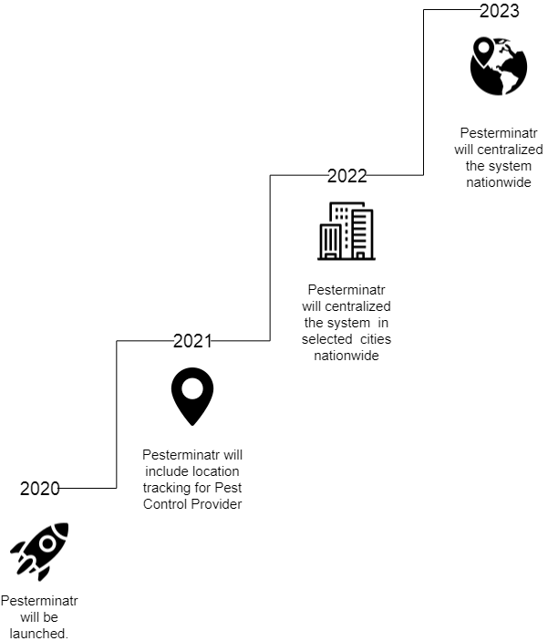

Figure : Roadmap

# **CONCLUSION**

To summarize, this system can help for you to easily select a Pest Control Provider to prevent and control the entrance of pests and predators and eradicate infestations in facilities housing or offices. For all their pest control services, inquire them. They are the ones who will provide pest management solutions to homes and businesses where you can request schedule for ocular inspection before the extermination, inquire their services, and give feedback to the provider. Pest Control Provider is also has the authority to advertise their services, and the one who will decide for your requested schedule.

**RECOMMENDATIONS**

Like most applications, Pesterminatr never attained perfection due to limited time and resources. The researchers and developers struggle to create an application that can confer with user needs and satisfaction. Pesterminatr has the basic functionalities needed for it to work and it is recommended for Beta testing. Feedback and reviews from the Beta testing will be used for the improvement of this project. Aside from the feedback provided by the recipients of the Beta testing, these are the following areas of improvement that is highly recommended for the proponents or future researchers who want to improve the study to do the following:

* Clients can book online through web or mobile.
* Clients can select list of Pest Control Provider.
* Clients can give feedback to the selected Pest Control Provider.
* Pest Control Provider can add different services through web.
* Pest Control Provider to accept requested service by the Client.

# **REFERENCES**

Asenova, I. (2018, April 02). *Clock*. Retrieved from Clock-Software Web Site: https://www.clock-software.com/blog/Benefits-of-online-booking-systems.html

Cocco, P. (2016, August). *Pesticides and Human Health*. Retrieved from Environmental Science: http://environmentalscience.oxfordre.com/view/10.1093/acrefore/9780199389414.001.0001/acrefore-9780199389414-e-82

Johnston, S. (2017, December 15). *Booking Alive*. Retrieved from Booking Alive Web Site: https://www.bookinglive.com/blog/why-use-an-online-booking-system

Lu, J., Cosca, K. Z., & Del Mundo, J. (2010, December 13). *Trends of Pesticide Exposure and Related Cases in the Philippines*. Retrieved from NCBI: https://www.ncbi.nlm.nih.gov/pmc/articles/PMC4309360/

Mallen, D. (2014, February 24). *Acteavo*. Retrieved from Acteavo Web Site: https://acteavo.com/blog/benefits-using-an-online-booking-system/

Me and My Shadow. (2015, September 21). *Me and My Shadow*. Retrieved from https://myshadow.org/computer-specification-hardware

ndbrown. (2018, January 23). *bookingalive*. Retrieved from bookingalive Web Site: https://www.bookinglive.com/blog/beginners-guide-to-online-booking-systems

Oakley, R. (n.d.). *USA Today*. Retrieved from Travel Tips USA Today Website: https://traveltips.usatoday.com/advantages-online-reservations-63078.html

Osterwalder, A. (2010, April 25). *Wikipedia*. Retrieved from Wikipedia Web Site: https://en.wikipedia.org/wiki/Business_Model_Canvas

*Pesticide Action Network UK*. (2017). Retrieved from Pesticide Action Network UK Web Site.

Reed, M. (2016, September 30). *Quora*. Retrieved from Quora Web Site: https://www.quora.com/Is-any-pest-control-treatment-effective

Rouse, M. (2011, November). *Tech Target*. Retrieved from Search Software Quality: https://searchsoftwarequality.techtarget.com/definition/iterative-development

Rouse, M. (2015, January). *WhatIs*. Retrieved from WhatIs Web Site: https://whatis.techtarget.com/definition/use-case-diagram

Technosys, E. (n.d.). *Quora*. Retrieved from Quora Web Site: https://www.quora.com/What-are-the-advantages-and-disadvantages-of-online-booking-systems

*Techopedia*. (n.d.). Retrieved October 6, 2016, from Techopedia - The IT Education Site: https://www.techopedia.com/definition/30186/network-design

*Toxics Action Center*. (1987). Retrieved from ORGANIZING WITH RESIDENTS TO CLEAN UP AND PREVENT POLLUTION: http://toxicsactionorg.live.pubintnet-dev.org/problems-and-solutions/pesticides

Wikipedia. (2018, October 21). *Wikipedia*. Retrieved from https://en.wikipedia.org/wiki/Integration_testing

Wikipedia. (2018, October 3). *Wikipedia*. Retrieved from https://en.wikipedia.org/wiki/Unit_testing

Wikipedia. (2018, October 3). *Wikipedia*. Retrieved from https://en.wikipedia.org/wiki/Unit_testing

Wikipedia. (2018, September 27). *Wikipedia*. Retrieved from https://en.wikipedia.org/wiki/Network_planning_and_design

Wikipedia. (2018, October 26). *Wikipedia*. Retrieved from https://en.wikipedia.org/wiki/Software_requirements_specification

# **CURRICULUM VITAE**



**Fhage Tigley**

Address: C. Padilla Street Cebu City, Philippines, 6000

Mobile No: 0933-533-6647

Email: [iamfhage@gmail.com](mailto:iamfhage@gmail.com)

PERSONAL INFORMATION

|  |  |
| --- | --- |
| Gender: Female | Religion: Christian |
| Age: 20 | Nationality: Filipino |
| Date of Birth: September 02, 1998 | Place of Birth: Minglanilla, Cebu |
| Father’s Name: Julius Tigley | Occupation: Self-Employed |
| Mother’s Name: Josephine Tigley | Occupation: Housewife |



**Christian Neil Tude**

Address: Brgy. Ermita Cebu City, Philippines, 6000

Mobile No: 0922-370-1189

Email: [tudechristian3@gmail.com](mailto:tudechristian3@gmail.com)

PERSONAL INFORMATION

|  |  |
| --- | --- |
| Gender: Male | Religion: Catholic |
| Age: 20 | Nationality: Filipino |
| Date of Birth: July 05, 1998 | Place of Birth: Cebu City |
| Father’s Name: Nilo Tude | Occupation: Decease |
| Mother’s Name: Pacita Tude | Occupation: Housewife |



**Julius Jay Buenavista**

Address: Cogon Pardo Sitio Laguna, Cebu City, Philippines, 6000

Mobile No: 0923-540-4182

Email: [jaybuenavista145@gmail.com](mailto:jaybuenavista145@gmail.com)

PERSONAL INFORMATION

|  |  |
| --- | --- |
| Gender: Male | Religion: Catholic |
| Age: 20 | Nationality: Filipino |
| Date of Birth: July 10, 1998 | Place of Birth: Cebu City |
| Father’s Name: Joaquin Buenavista | Occupation: Land Agent |
| Mother’s Name: Juvy Buenavista | Occupation: Sales Agent |

# **APPENDICES**

## Appendix A: Capstone 41 Oath of Confirmation Form





## Appendix B: Capstone Project Team Composition Form

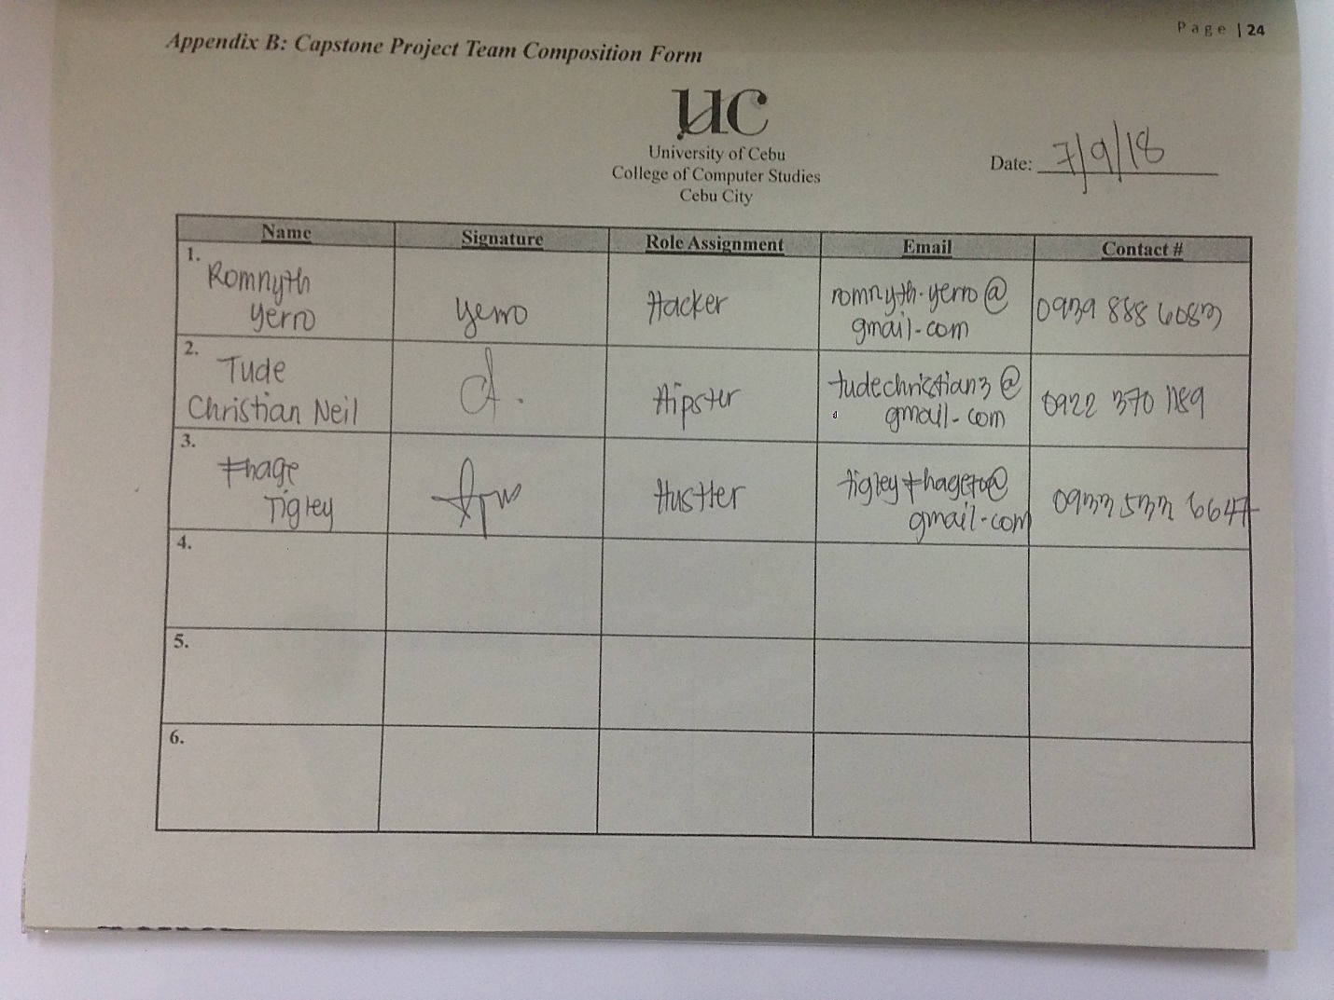

## Appendix E: Capstone Project Working Title Form

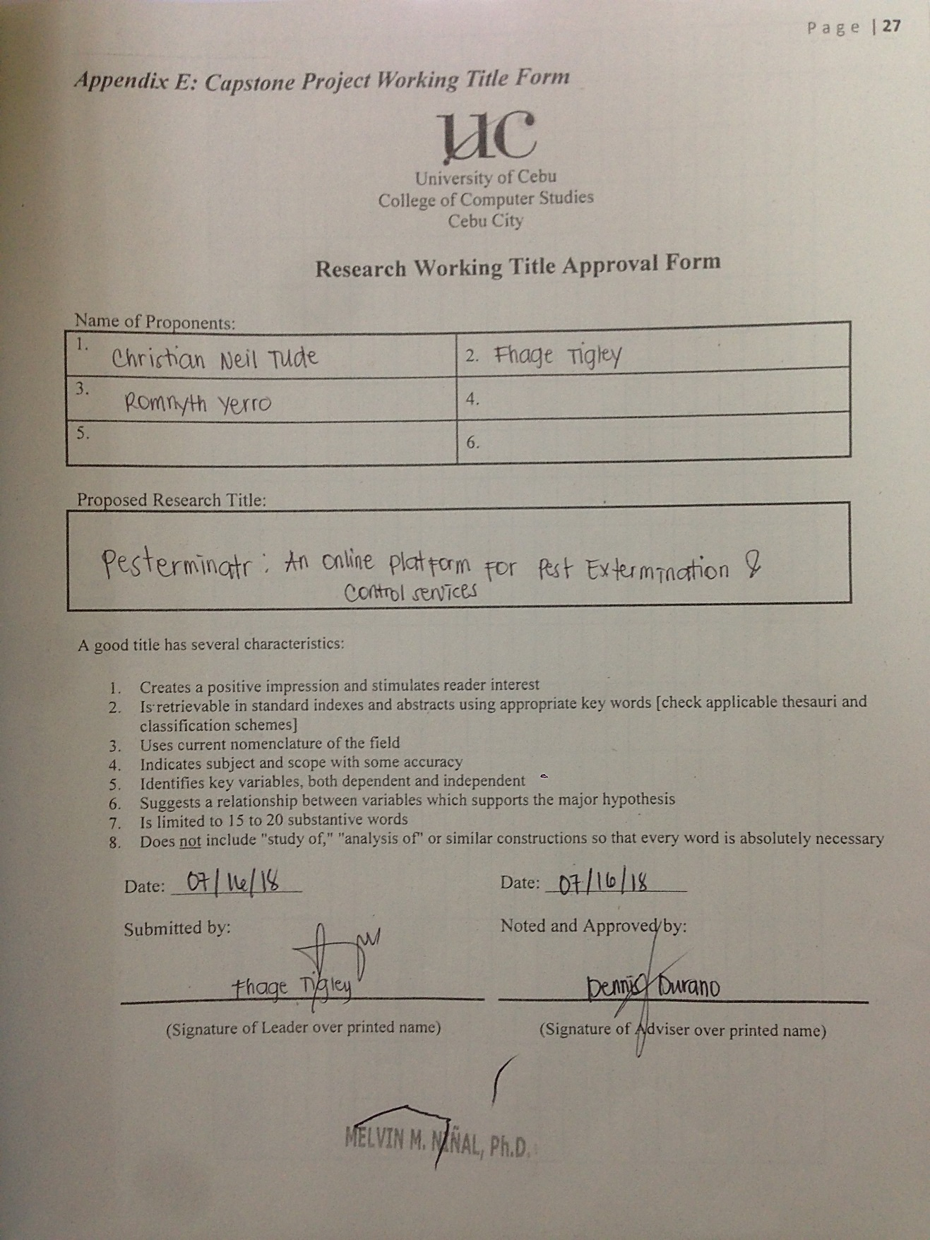

## Appendix G: Capstone 41 Logs Form

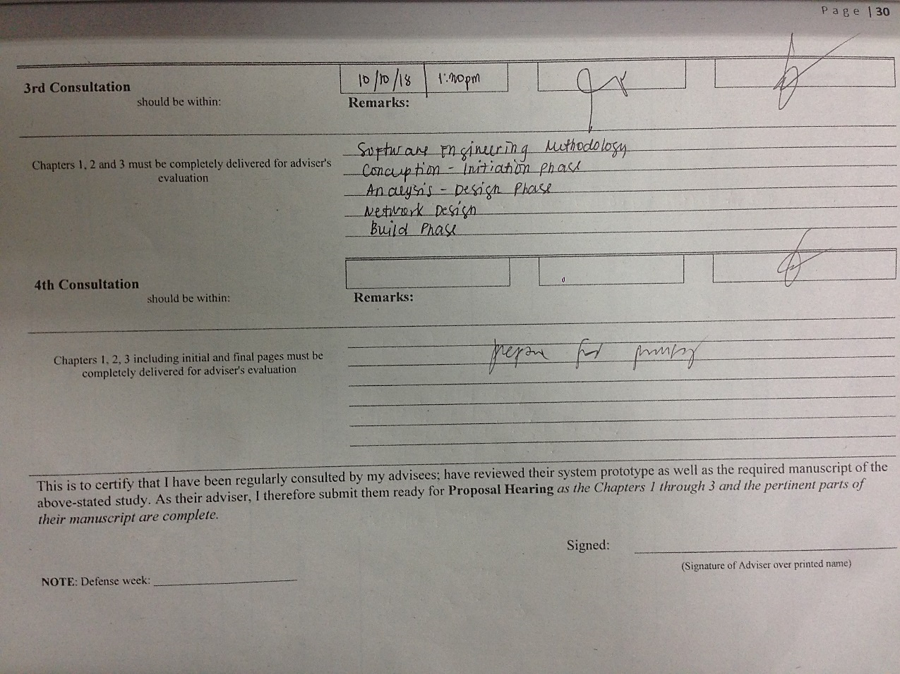

## Appendix H: Censor’s Certificate Form

